Name: Scott Mitchell

Module: CSN

Class: CSN 24/25

Title of Assignment: Assignment 2A

**Table of Contents**

1. **Initial Planning**
2. **Objective of Website**
3. **Design Sketches**
4. **Software Used**
5. **U.I Design**
6. **Conclusion**

Initial Idea for your 12 Page Website.

*I am writing a 12-page website on cyberpunk 2077 and the lore that surrounds Night City and the legends that lived and died in this city.*

Target Audience

Gamers, Tech Heads, D&D

Age Categories of Target Audience

*15 to 35*

Type of content are they interested in

*The content my users are interested in is the in-depth history of Night City as well as an in depth guide to survival in these harsh chrome filled streets.*

List 3 site objectives – Why are you making a website for this Market/Audience

* 1. Objective 1.

*Educate people on the massively in-depth lore of cyberpunk*

* 1. Objective 2.

*Provide a fresh perspective on the game and how to best approach night city*

* 1. Objective 3.

*I am also promoting the game by writing this website because I will give this game and genre all the free advertising it wants*

Sketch a basic Wire Frame Diagram to illustrate your Site Structure

*Produce a Wire-Frame Diagram. Hand-drawn with care – using a Ruler. And/or produce a Diagram in word, Excel, etc and place it in this section. Include some notes on the structure to support your diagram.*

Goals/Affiliation

Friendly members

Main Charcas

Customization

V’s Storyline

CORPOS

Factions

Main Characters

Contact/Review Page

More Lore & selling point

Corporations aim

Secret Tech

Sketches of Initial Design Concepts

Identify tools for creation and maintenance of website including:

1. HTML and CSS

*I will be using visual studio code to create and maintain my website*

1. Graphics

*Any photo editing I do will be done in the free editing software included with windows 11*

1. Site uploading

I will use FTP to Upload my site. Depending on the WWETB firewall, I intend to use FileZilla as my FTP software.***FTP (File Transfer Protocol)****is a standard network protocol used for the transfer of files from one host to another over a TCP-based network, such as the Internet. FTP works by opening two connections that link the computers trying to communicate with each other* ***[2024, Fortinet****.*

Explain the Importance of the following in User Interface Design:

*This section was covered on a PowerPoint Presentation in Class and is also available on Moodle. It will provide an opportunity for you to demonstrate your knowledge of basic graphic design fundamentals. You should explain each subject and if possible, include an picture to demonstrate the different design principles.*

1. Contrast

*Contrast in UI Design refers to the relationship between two or more design elements, like text and background that are noticeably different from one another. It more emphasizes on the differences between these elements rather than their likeness.*

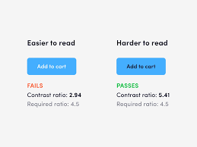

1. Repetition

*Repetition is what brings consistency to designs and depending on how it is used it can add energy to composition. E.g. Googles logo which uses colours in its logo that are recognizable on its other logos.*



1. Alignment

*Alignment essentially helps organize elements and improve legibility and user interaction. Provides visual structure to the design making them consistent and logical. E.g. Either aligning the elements to right, left or to the centre margin.*

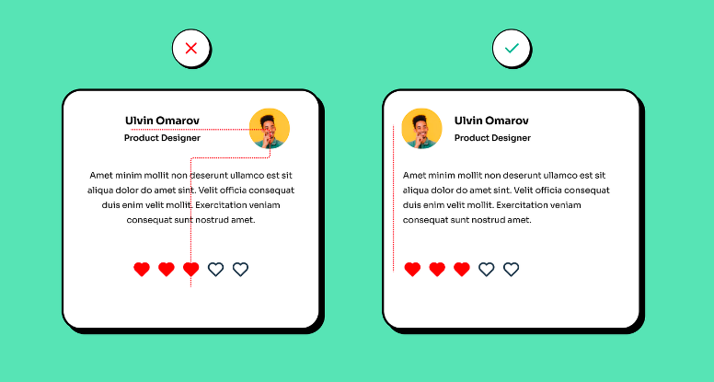

1. Proximity

*Proximity is when you place related attributes near each other. This allows users to draw comparisons and make informed decisions effortlessly. E.g. the NBC peacock logo is a collection of separate images that appear to make a whole based on proximity.*

Summary:

*The website will be based aesthetically around cyberpunk and its lore I might even use a lot of the 2077 slang throughout my webpages to draw you into the feeling of Night City. This website will be made available to those who wish to learn more about the inner workings of all the biz floating around the gonk filled cesspools of Night City. The U.I will solely be based on the looks of cyberpunk to give the in depth feel for all users.*